X660 Quick Installation Guide

Appearance Instructions
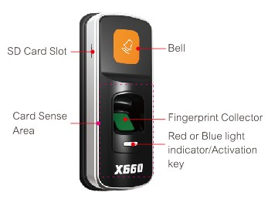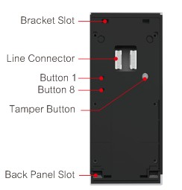

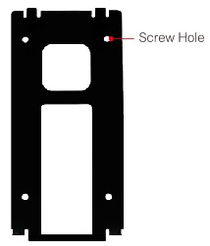
Reminder: 1.Avoid any direct sunlight to fingerprint collector; 2.When button 1 or 8 is pressed, use small round thing to enter into the hole to press.
Installation
1. Follow the 4 screw position of the back panel (enclosed in the standard package) to drill the relevant screw holes on the wall.
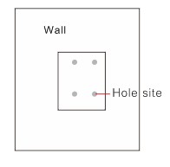
2. Put wall plug into the 4 drilled holes, make the 4 screw hole of the back panel match the relevant hole position on the wall, and then use self-tapping screw to fix the panel on the wall.
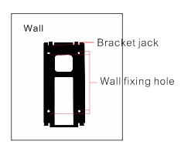
3. To adapt the bracket slot to the bracket jack, pull down the device to get them perfectly matched.
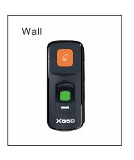
Wiring Diagram
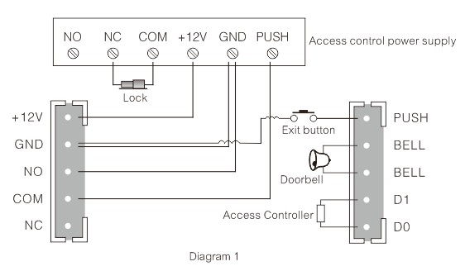
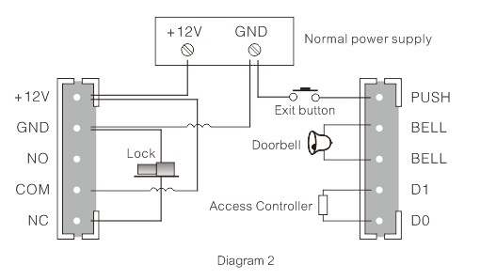
Note: The figure 1 is for exclusive access power wiring diagram; graph 2 is for normal power wiring diagram. Access control power supply is always recommended.

Create New User
Step1: Power on the device and enter the standby state.

Step 2: In the normal mode, first unscrew the back cover and press and hold the dismantlement round button, press 8118 on the back of the device, and then the blue light flashes, it enters the registration of "add permissions", press 3 times with the same finger (or swipe card directly), as two short “Di Di” beeps are heard, it indicates that the registration is successful; once a long " Di- " beep is heard, it indicates registration is failed, please register again.

Step3: Registration of fingerprint or card with “Deleting permission”. In the normal operating mode, press 1881 on the back of the device, and then the blue light flashes, it enters the registration of "Deleting permission”, press 3 times with the same finger (or swipe card directly), as two short “Di Di” beeps are heard, it indicates that the registration is successful; once a long " Di- " beep is heard, it indicates registration is failed, please register again. (Note: The user must first register separately at least an "Adding permission" and a "Deleting permission” fingerprint (or card), and then it's available to register the normal user. For a device, there are maximum 2 fingerprints (or 2 cards) are allowed to be registered as adding or deleting permission, meantime fingerprint or card with “Adding or deleting permission” can not open the door.)

Step 4: Register a new user. In the normal mode, first press the "Adding per-mission" fingerprint (or swipe card directly), When recognition is successful, the red light flashes, it's available to add a new user. Press 3 times with a finger (or swipe card directly), as two short “Di Di” beeps are heard, it indicates that the registration is successful; once a long " Di- " beep is heard, it indicates registration is failed, please register again. (Note: Continuous registration of new users is allowed; 6 seconds without any operation, it returns to the normal state)

User Deletion
Two modes of user deletion
- In the normal mode, first press the “Deleting permission" fingerprint (or swipe card directly), When recognition is successful, the red light flashes, Pressing the fingerprint need to deleted (or swipe card directly), a as two short “Di Di” beeps are heard, it indicates that the registration is successful; once a long " Di- " beep is heard, it indicates registration is failed, please retry. (Note: When it enters deleting user process, it's allowed to continuously delete users. 6 seconds without any operation, it returns to the normal state) Once continuously press fingerprint of "Deleting permission" for three times, all the registered fingerprints will be deleted from the device (Except for fingerprint of "Deleting permission" and "Adding permission)
- By software: Use SD card to download all enrolled data, use PC software to delete user and then use SD card to upload the modified enrolled data to the device. (In the software, user name is allowed to be input)
Clear Administrator
First power off the device, press button8, and then get the device power on, after 3 seconds, all the fingerprint/card with “Adding permission” or “Deleting permission” will be automatically cleared.
SD Card Operation Of Uploading Downloading Registration Data
Download all registration data from the device to the SD card:
Step 1: Insert SD card into the relevant slot.
Step 2: Press "Adding Permission” fingerprint (or card), when the recognition is succeed, it will automatically download all the registration information to the SD card, say, the blue light is on for 1 second whereas the red light is off, and two short “Di Di” beeps are heard, it means the
downloading is successful; say, the red light is on for 1 second whereas the blue light is off, and a long " Di- " beep is heard, it means the downloading is failed, please re-download.
Upload all registration information from the SD card to the device:
Step 1: Insert SD card into the relevant slot.
Step 2: Press “Deleting Permission” fingerprint (or card), when the recognition is succeed, it will automatically upload all the registration information to the device, say, the blue light is on for 1 second whereas the red light is off, and two short “Di Di” beeps are heard, it means the uploading is successful; say, the red light is on for 1 second whereas the blue light is off, and a long " Di- " beep is heard, it means the uploading is failed, please re-upload.
Initialization
In the normal operating mode, first unscrew the back cover and press and hold the dismantlement round button, press 8111, and the red and the blue light are keep flashing, the buzzer sounds three long and two short beep "Di - Di - Di – Di Di" , it enters initialization mode. Once initialization is really required, press the number keys 8 to get it done, or it's required to cancel this operation, press the reset button or wait six seconds without operation that it returns to normal operating mode.
Security Level Setting
Under normal mode, press digit combination 88811, then N times of 8 and then press 1. N means the security level and press key 1 to confirm the setting. For example: Set security level as 4, first press 88811, second press 8 four times and finally press 1. The maximum for N is 5 and the defaulted level is 3.
Set Lock Drive Mode
For current relay duration is 6 seconds, although it can meet most of striker locks or magnetic locks requirement. However for those other electric lock which is only with 500ms pulse, the long duration may get the device damaged, therefore it’s necessary to have unlocking drive mode setting:
Conversion mode: After recognition, the relay action duration is only 500ms, to set this by pressing digit combination of 11188.
Setting Up Door-opening Delay
Press and hold the dismantlement round button, and next press the digit combination of "1118" at the back of the device, and then continuously press key "1", remember, each additional time key "1" to be pressed, it means an increase of 0.5 second in delay time (Remark: Each additional time key "1" to be pressed, it means an increase of 0.5 second).
Technical Specifications
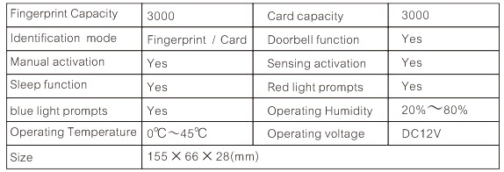
Hint: After power on the device, once the tamper alarm is not started, no need to press and hold the tamper button during the operation. (After power on the device, press tamper alarm button once then the tamper alarm is started)

